Task Management System

TaskManager is a full-stack web application built using the Model-View-Controller (MVC) architecture. It allows users to create, organize, assign, and track daily tasks and project milestones.

WorkFlow

When the project starts there is a login page for an employee. In this section when an employee is already created through the HR Team. After employee creation the employee needs to create a user and password for it.

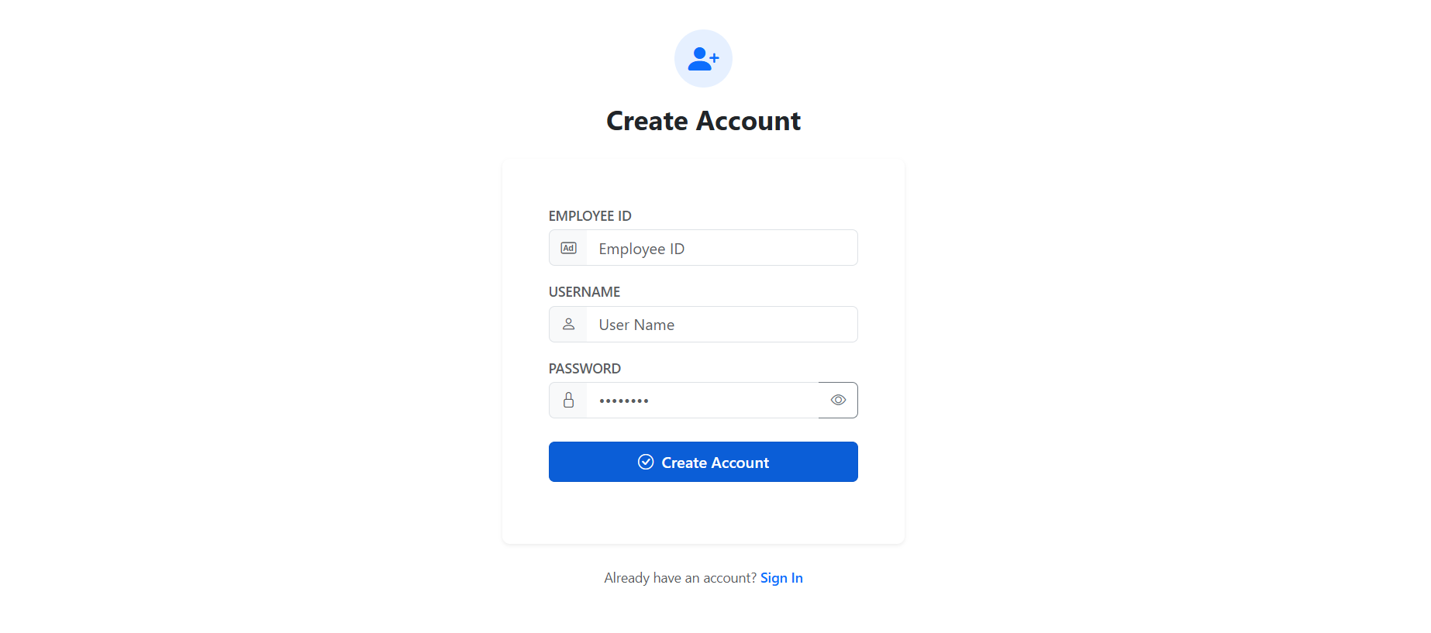

After creating the password and user name that user can use the task management application.

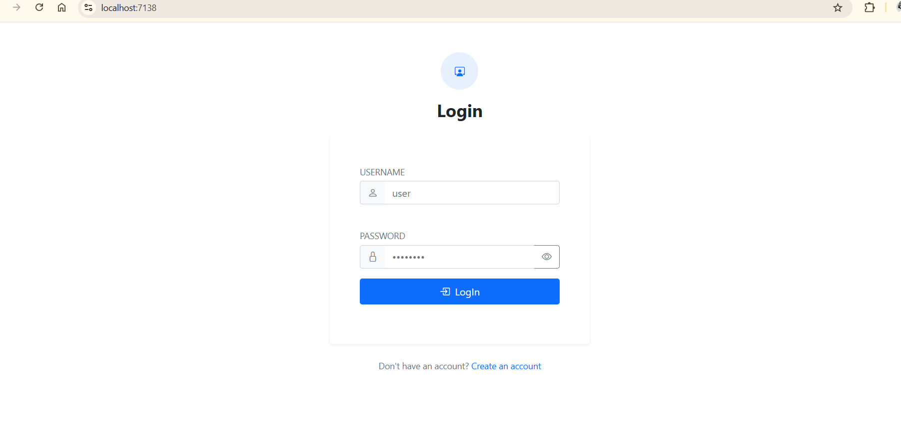
After Login, enter the dashboard page. This provides the Task count which is separated by the task nature. That are:-

Total Task
New Task
In Progress
Completed Task
OverDue Task

And also providing the overdue work/task list for notify the employee. It is essential for reviewing their performance, maybe go average.

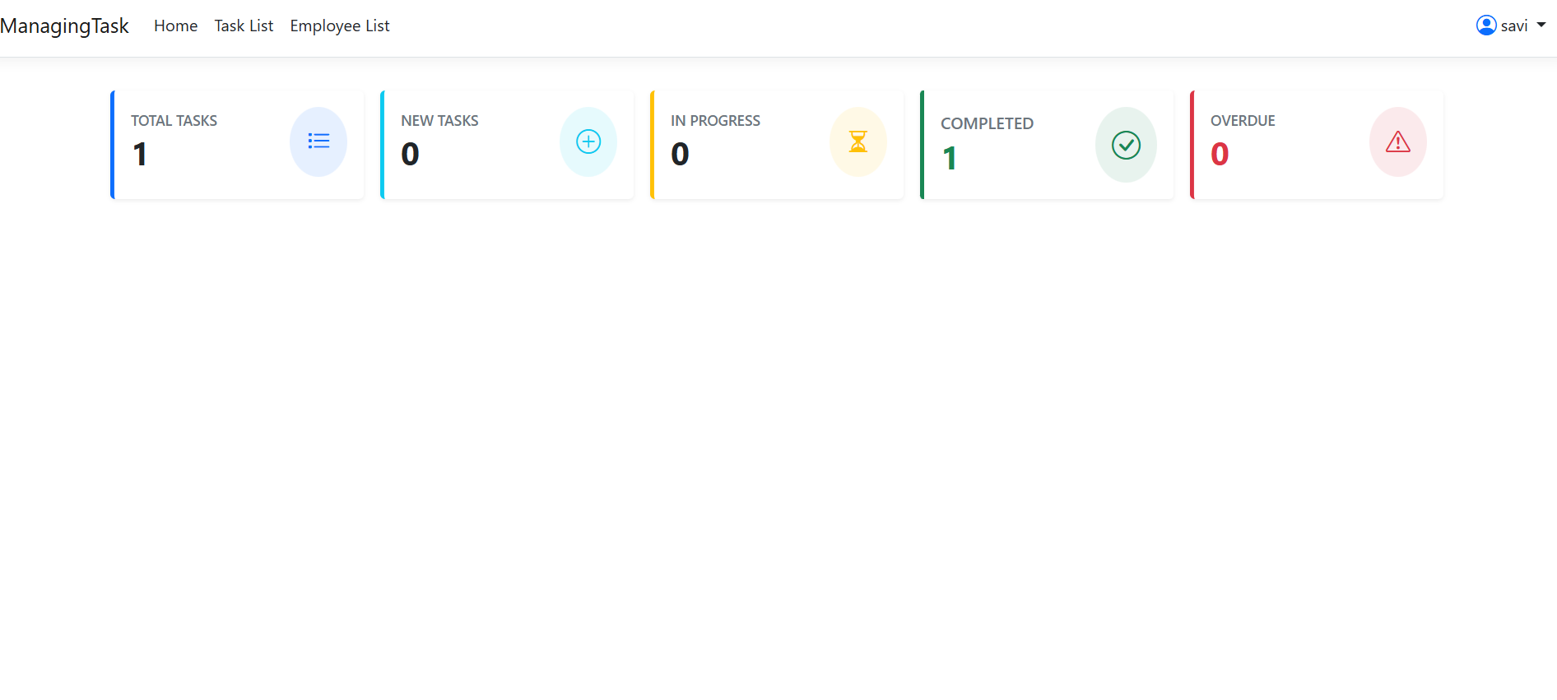

When the employee clicks the task details we provide a detailed task List for reviewing their task. And also there provide an option for creating new Tasks to assign employees. This option only provides an Admin panel.

An employee has a number of tasks with different priorities and have different Status.
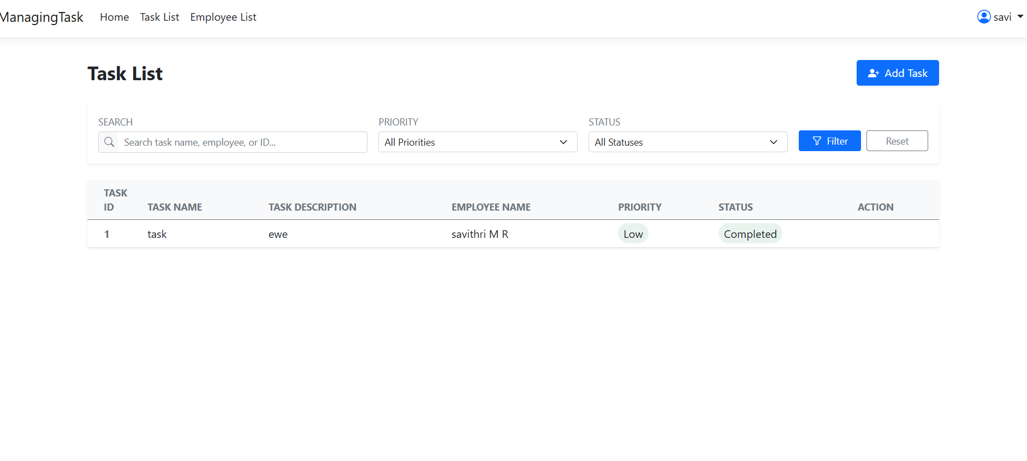

We can filter with different types which is more easy to find a data with preferred types.

And also marks the task as a completed option for every employee. But the other options are provided to Admin Panal. When we click the button “Mark As Complete” the status will update to complete.

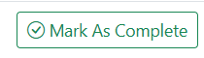

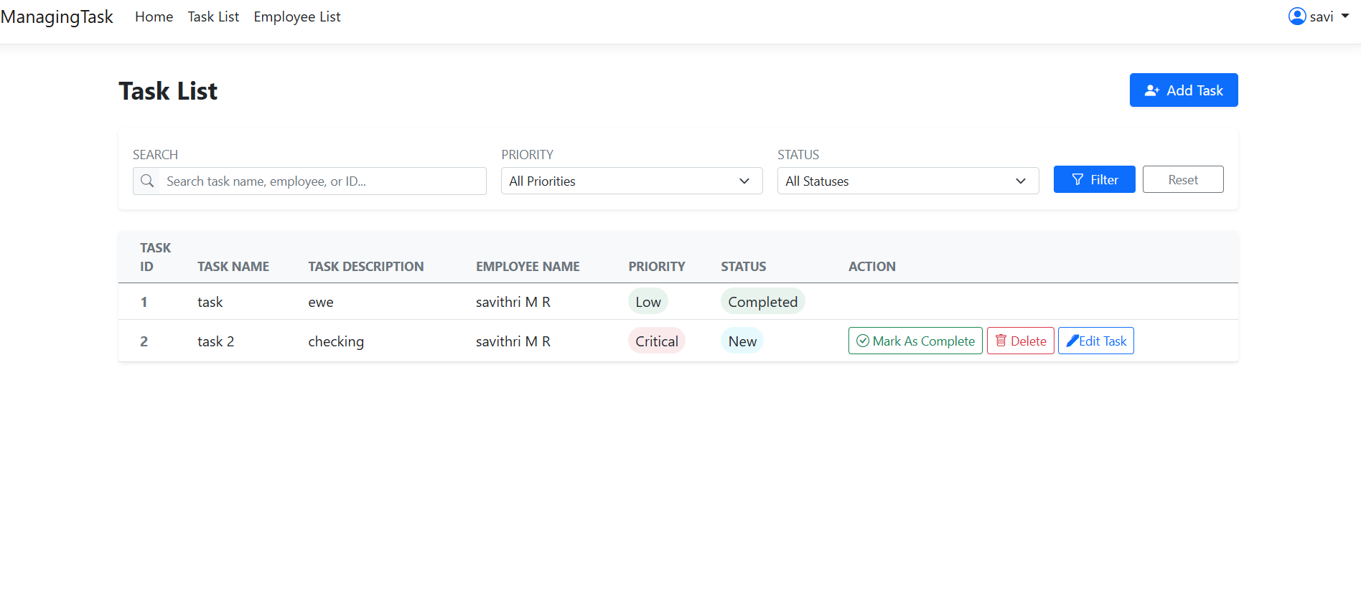

When an Admin clicks the “Delete” button the task will be deleted. If the task Mark As completed the task does not deleted.

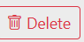

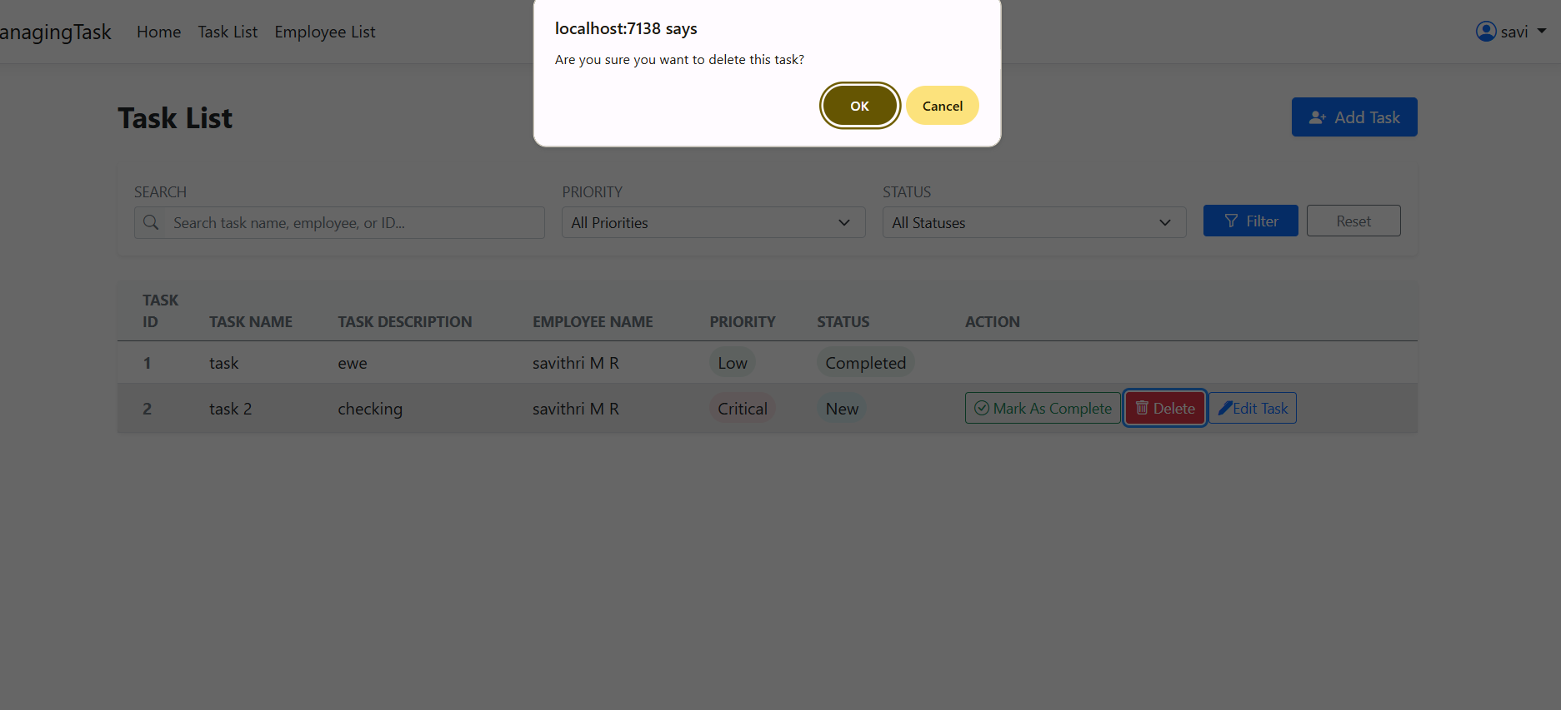

When clicked the “Edit” Button Admin can edit the task details. If make a change it will reflect the task List Also.

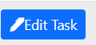

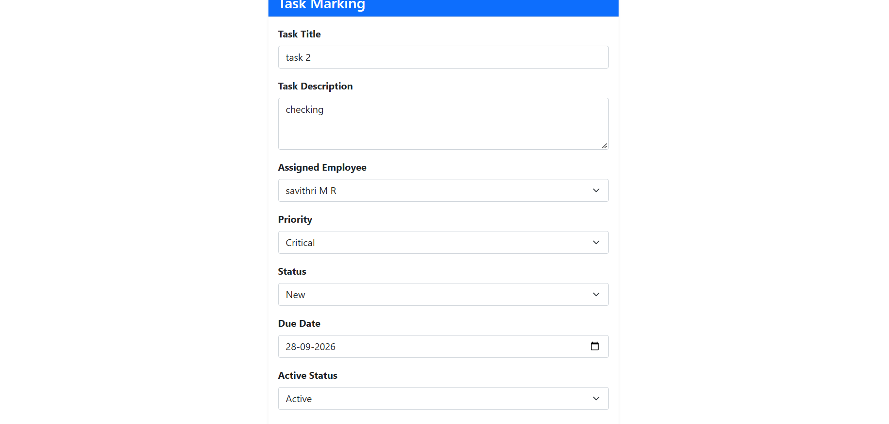

If Admin needs to create the task he can click the Create Task Button in the Task List. After clicking the create task button it will redirect to the provided page.

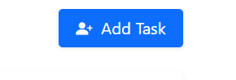

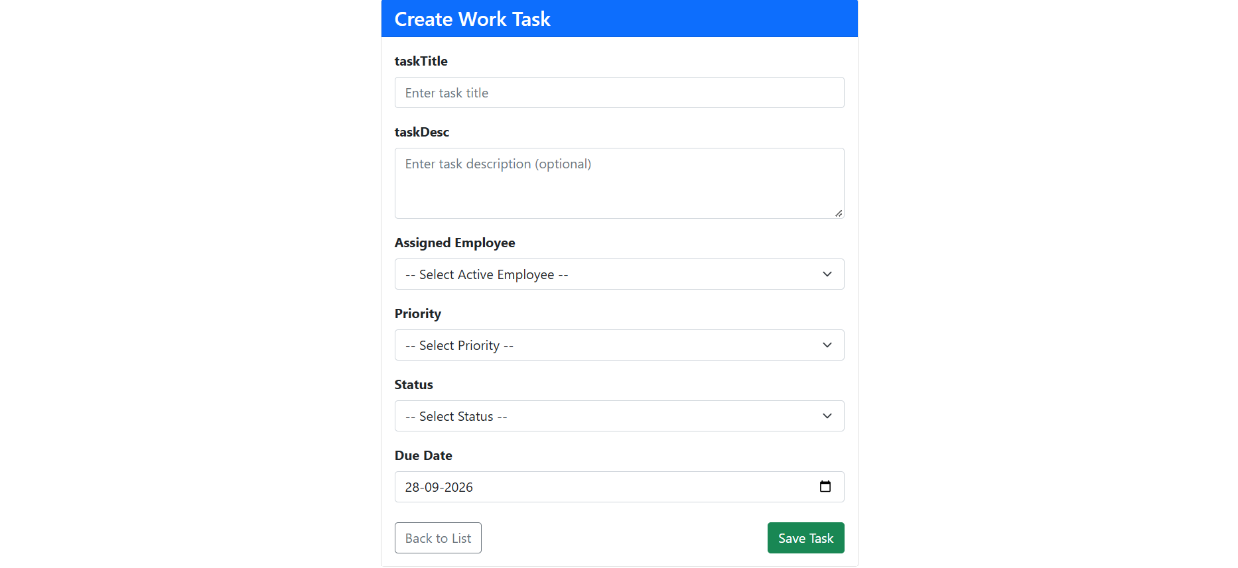

There is another section for Managing the Employees. This module provided employee details in an organisation.

We can search with employee name which makes it much easy to find out an employee.
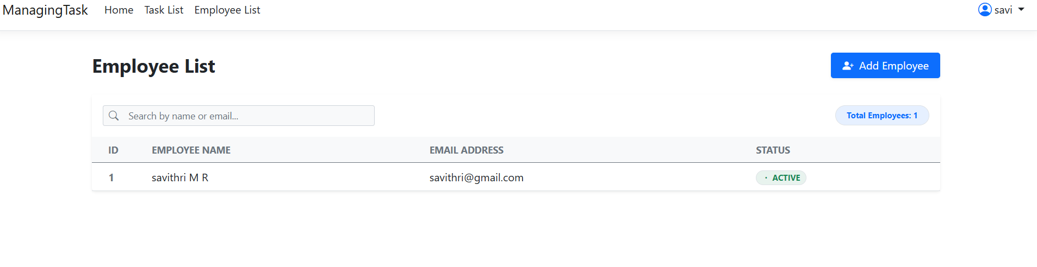

There is shows how many employees belongs to this organisation.

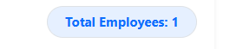

If HR needs Add New Employee click the provided button below.

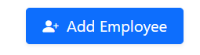
After clicking the Add Employee Button it will redirect to the Create Employee page. In this there FirstName, LastName, Email Address and the status of Employee.

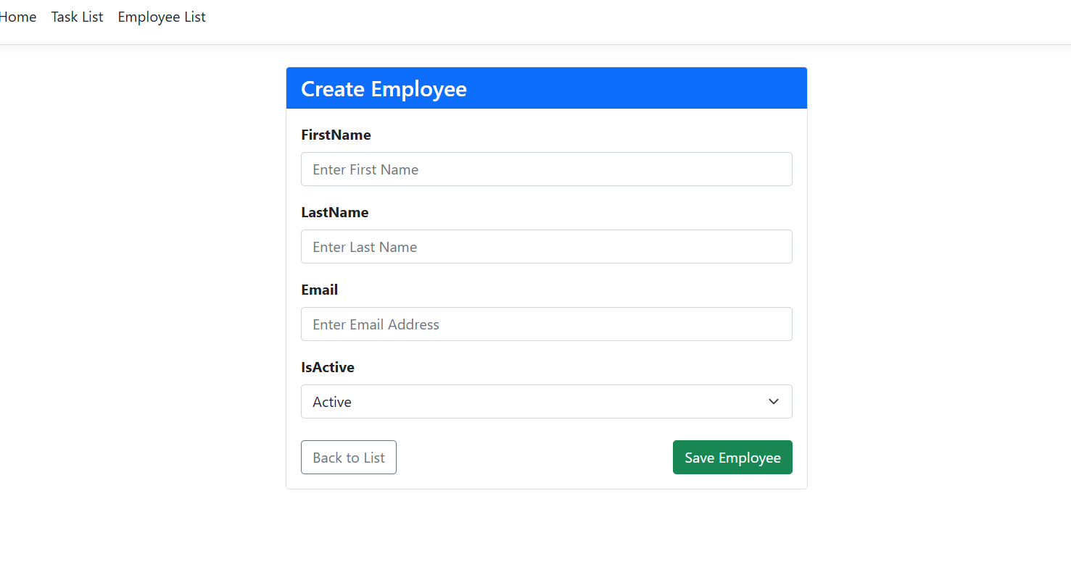

1. Models Layer

Defines individual tasks, validation constraints, and database relationships.
- Attributes:
  - taskId (Primary Key)
  - taskName (String)
  - taskDesc (Text, Optional)
  - taskStatus (Status are :- Pending, In Progress, Completed; Pending)
  - taskPriority (Priorities are :-: Low, Medium, High,Critical, Medium)
  - duedate (DateTime)
  - createdDate(DateTime)
  - completedDate(DateTime)
  - empId(Foreign Key $→$ User.id)
  - isActive(string)
- Relationships:
  - Task belongs to a Employee (empId)
  - Task belongs to a Status (taskStatus)
  - Task belongs to a Priority (taskPriority)

2. Controllers Layer
- TaskController
1. Index(): Views/Tasks/Index
2. .createTasks(): Renders Views/Tasks/CreateTask
3. MarkAsCompletepage: Edit Task Page fetch a task by its ID Views/Tasks/MarkAsCompletepage
4. edit(id): Fetches single task by ID $→$ Renders Views/Task/Edit
5. deleteTask(id): Deletes specified task data

- EmployeeController
- Index() :- Views/Employee/Index
- createEmployee() :- Views/Employee/createEmployee

- LoginController
1.. Index() :- Views/Login/Index
2. createAccount(createAccountResquest request) :- Views/Login/createAccount

DataBase

Tables :

CREATE TABLE Employee (
empId VARCHAR(50) NOT NULL PRIMARY KEY,
empFirstName VARCHAR(100) NULL,
empLastName VARCHAR(100) NULL,
emailId VARCHAR(150) NULL,
isActive VARCHAR(1) NULL,
createdDate DATETIME NOT NULL DEFAULT GETDATE()
) ;

CREATE TABLE Priority (
priorityId VARCHAR(10) NOT NULL PRIMARY KEY,
priorityName VARCHAR(10) ,
isActive VARCHAR(2) NULL
) ;

CREATE TABLE Status (
statusId VARCHAR(10) NOT NULL PRIMARY KEY,
status_Name VARCHAR(10) ,
isActive VARCHAR(2) NULL
) ;

CREATE TABLE WorkTask (
taskId VARCHAR(50) NOT NULL PRIMARY KEY,
taskName VARCHAR(150) NULL,
taskDesc VARCHAR(2000) NULL,
taskStatus VARCHAR(10) NULL,
taskPriority VARCHAR(10) NULL,
empId VARCHAR(50) NULL,
dueDate DATETIME NULL ,
createdDate DATETIME NOT NULL,
completedDate DATETIME NOT NULL,
isActive VARCHAR(2) NULL ,
) ;

CREATE TABLE LogIn(
LogId VARCHAR(100) NOT NULL PRIMARY KEY,
userName VARCHAR(100) ,
password VARCHAR(100) NULL,
empId VARCHAR(50) NULL,
loginRole VARCHAR(50) NULL,
) ;

Sequence :

CREATE SEQUENCE EmployeeSequence
START WITH 1
INCREMENT BY 1
MINVALUE 1
MAXVALUE 9999
NO CYCLE
CACHE 20;

CREATE SEQUENCE TaskSequence
START WITH 1
INCREMENT BY 1
MINVALUE 1
MAXVALUE 9999
NO CYCLE
CACHE 20;

CREATE SEQUENCE LoginSequence
START WITH 1
INCREMENT BY 1
MINVALUE 1
MAXVALUE 9999
NO CYCLE
CACHE 20;

